**JECRC – 45 Days In-campus Training (4 Semester)**

**Subject – Full Stack Web Development**

# Day 7: 22th May, 2024

# Topic – position

**Assignment 5:-**

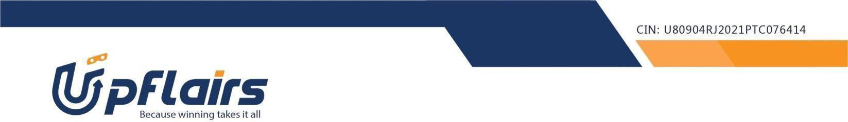 1. make the following webpage -

https://www.html.am/templates/downloads/preview.cfm?template=css-templates/fixed-width-2-blue.cfm

Note-upload your code to your github repo and share the url

Assignment submission form link - https://forms.gle/SahfKH2wGTmBpeHv8